DEV Log.

Part 1. Main Menu
We start the project by making a simple Main Menu.
The design is a simple 4 buttons to access the different point we need.
We decided on the following array:
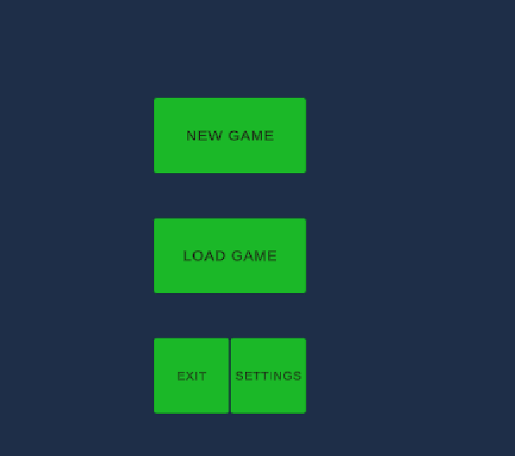
After creating the art for the button:
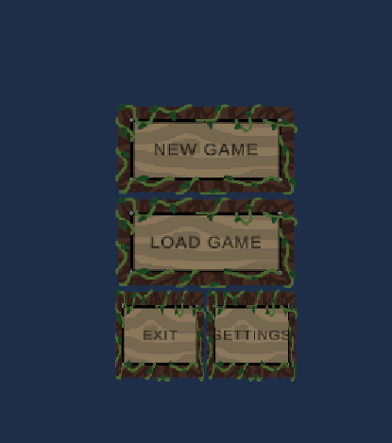
We created the logic, so it starts the MainScene when NewGame and LoadGame are initialized.
We decided that it moves with the wasd and the arrow keys and selects with the enter, but it can be changed in the future simply on the inputs menu.

Part 2. Main Scene.
We decided to make the game like a theater play, where you fight the enemies and when you defeat them, curtains come from the side and close. Then we will restart the scene, repopulate it and the curtains will go away.
The scene has a wall and a floor. Obstacles will be both 2D (bushes and barricades) and 3D (boxes and rocks). They will be on the floor and provide cover for both the player and the enemies.
The player has a weapon. To attack, he presses the TAB key to focus on an enemy (souls-like mechanic) and press the Left mouse button to attack.
It has to be noted that all keys are subject to change and may or may not be able to be changed on the settings menu.
The player will be moved in a paper Mario-like way on that it is 2D. We will use the X axis as the horizontal plane and the z axis as the depth.
The camera is set to 0 degrees of rotation but on an elevation so depth can be perceived.
The first iteration of the main scene is:
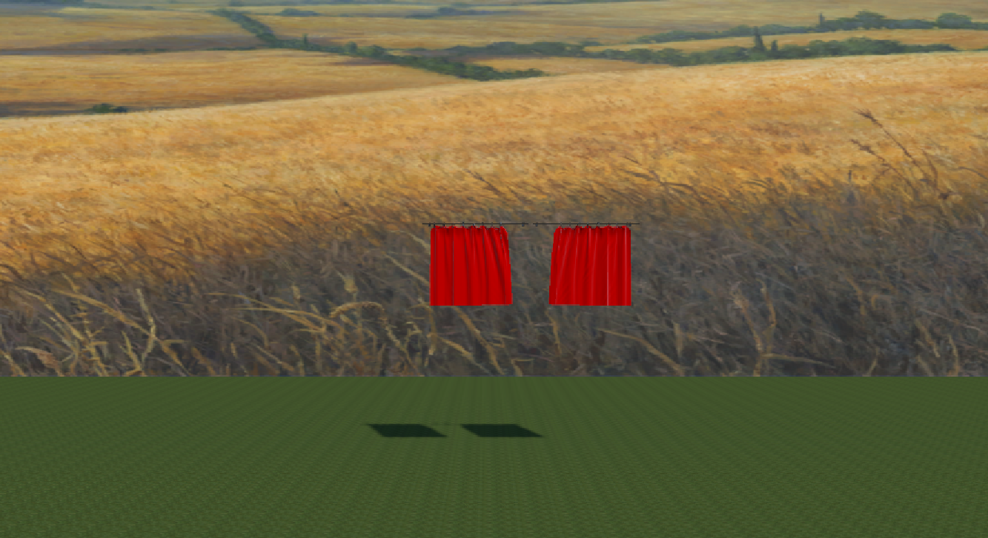
The curtains are the same, but one is scaled -x so it is mirrored.

Part 3. Character design.
We decided to use the models we found in unity for the player and enemies.
Also, we found some bows on pinterest and sliced them on different bows:
